**How to connect to an EC2 Instance:**

**1. EC2 Instance Connect:**  
Securely connect to your Amazon EC2 instances directly from the AWS Management Console using a web browser-based terminal.

* Open the EC2 dashboard in the AWS Management Console, select your instance, and start it. Wait until the instance status changes to "running."

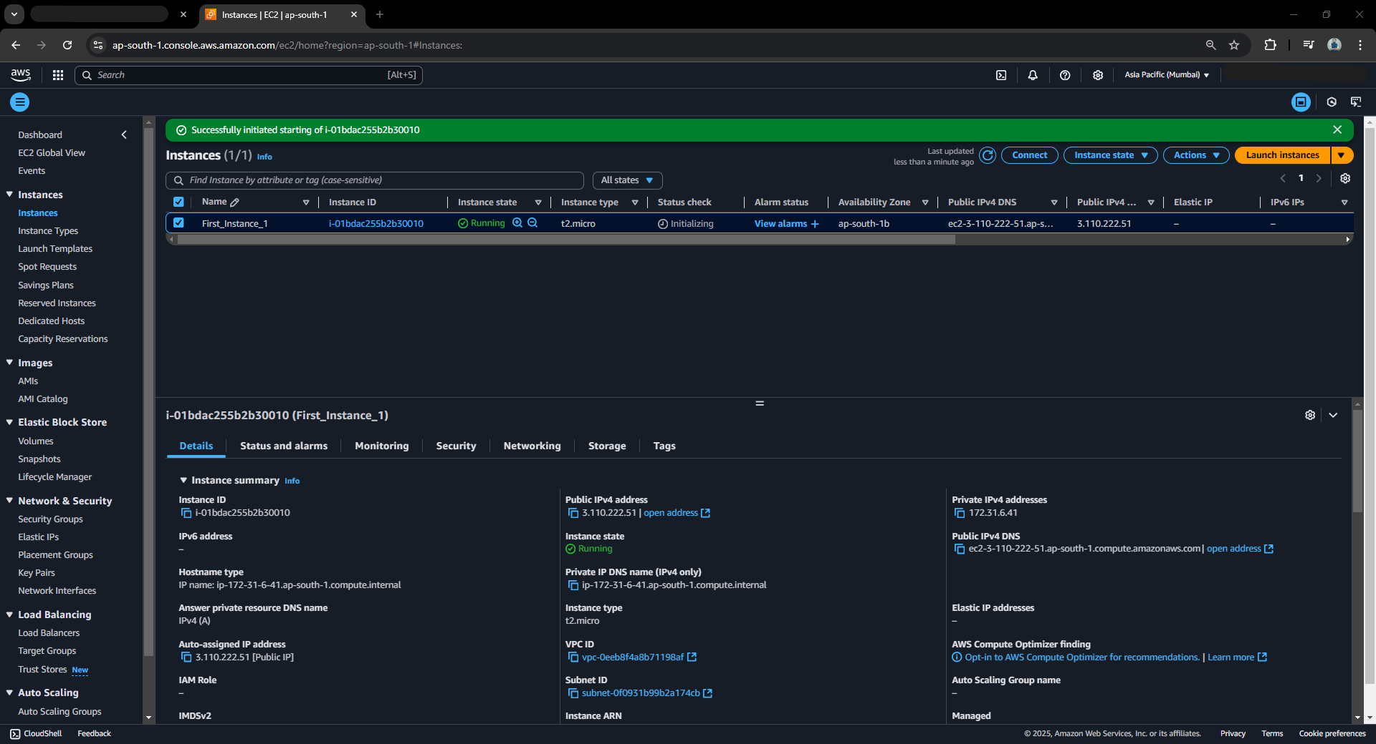

* Select **EC2 Instance Connect**, then choose **Connect using EC2 Instance Connect**. The username should be ec2-user. Click on **Connect**.

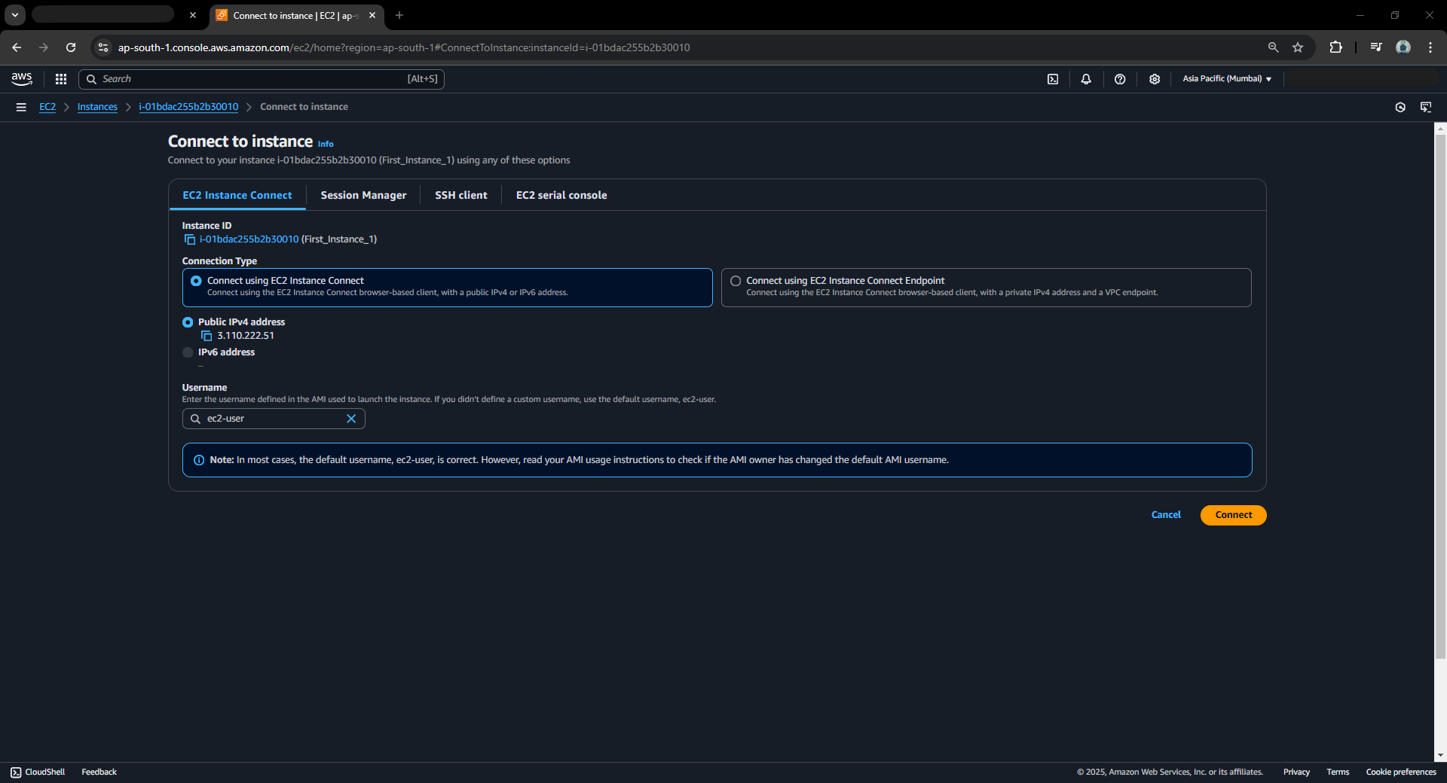

* A new tab will open, establishing a connection to the instance.

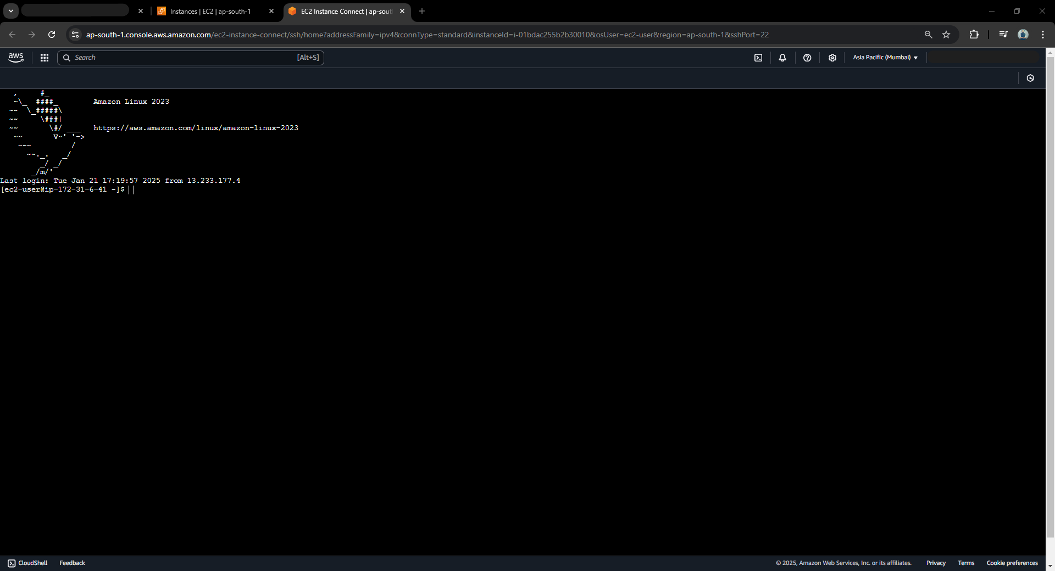

**2. PuTTY: SSH**  
SSH allows you to control and connect to a remote machine using the command line. We will use PuTTY for SSH access. If you have downloaded the .pem file for the key, use PuTTYGen to convert it into a .ppk file.

* Open PuTTY.

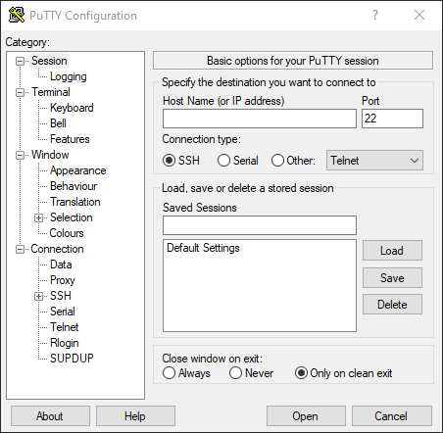

* Enter the hostname as ec2-user@<IP address> (e.g., ec2-user@3.110.222.51), and name the session.
* In the PuTTY configuration, go to Connection > SSH > Auth > Credentials. Then browse to select the .ppk file for Private key file for authentication.

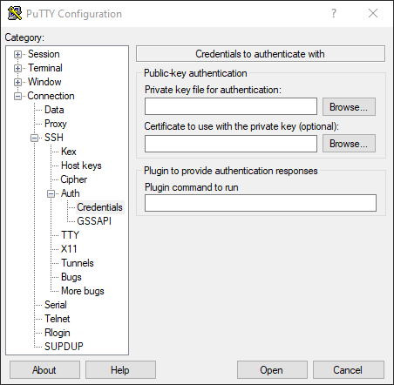

* Go to Session, name the session, and save it. Then, click Open.

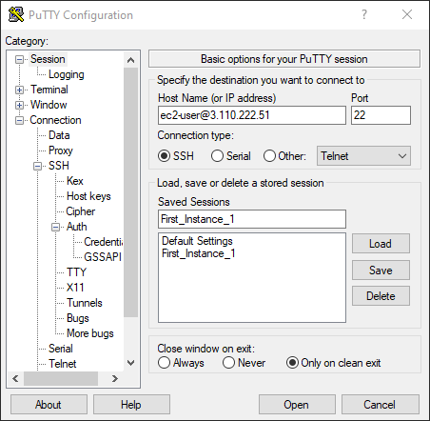

* A new tab will open, establishing a connection to the EC2 instance.

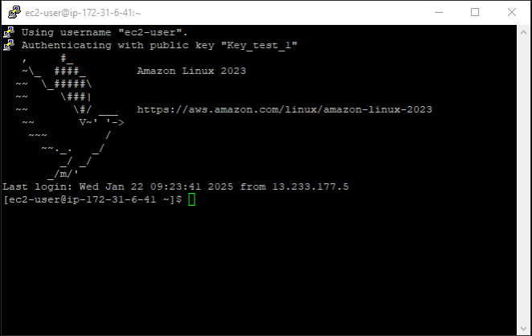

**3. SSH from Windows**  
SSH allows you to control and connect to a remote machine directly from Windows using the command line.

* Ensure that SSH is installed on your Windows machine.
* Navigate to the folder where the key file is saved.
* Run the following command in the terminal:  
  ssh -i .\<name_of _key> ec2-user@<public_ip>  
  This command specifies that you want to connect to the given IP using the ec2-user and the provided key for authentication.

